Project Design Phase
Solution Architecture

Date | 25 September 2026
Team ID | SWTID-2026-1147
Project Name | AI-Study Buddy
Maximum Marks | 4 Marks

Solution Architecture:
Solution architecture is a complex process – with many sub-processes – that bridges the gap between business problems and technology solutions. Its goals are to:
- Find the best tech solution to solve existing business problems.
- Describe the structure, characteristics, behavior, and other aspects of the software to project stakeholders.
- Define features, development phases, and solution requirements.
- Provide specifications according to which the solution is defined, managed, and delivered.

AI StudyBuddy - Solution Architecture Diagram:

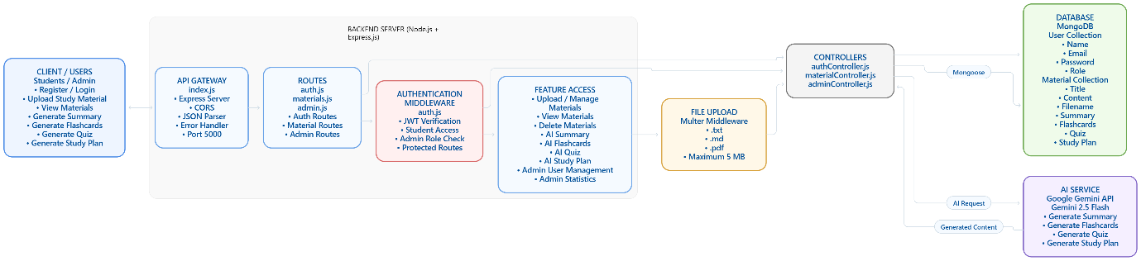
Figure 1: Solution architecture of the AI StudyBuddy backend, showing the client application, API gateway, authentication middleware, feature/controller layer, file upload middleware, AI service integration with Google Gemini, and the MongoDB database.
Component Description:
- Client Application: A React.js frontend where students and admins register, log in, upload study material, and access AI-powered features.
- API Gateway / Express Server: Node.js and Express.js receive HTTP requests, apply CORS and JSON parsing, and route them to the correct handlers.
- Authentication Middleware: JWT-based middleware verifies user identity, protects private routes, and enforces role-based access for students and admins.
- Feature / Controller Layer: Route handlers and controllers manage study-material upload/management, AI feature requests, and admin operations.
- File Upload Middleware: Multer-based middleware validates and accepts .txt, .md, and .pdf study material uploads up to 5 MB.
- AI Service Layer: A dedicated service communicates with the Google Gemini 2.5 Flash API to generate summaries, flashcards, quizzes, and study plans.
- Database Layer: MongoDB with Mongoose ODM stores user accounts, uploaded study materials, and AI-generated summaries, flashcards, quizzes, and study plans securely.

